TELCO CUSTOMER SEGMENTATION USING
K-MEANS CLUSTERING
PROJECT REPORT

BY
GROUP 20
DATA ANALYST


INTRODUCTION
Customer segmentation is an essential analytical approach in the telecom industry to understand the diversity among users and to create targeted customer-centric strategies. Telecom companies face challenges such as customer churn, increased competition, and the need for customized services.
This project focuses on building an unsupervised clustering model using the Telco Customer dataset to categorize customers based on characteristics such as demographic profile, income level, call usage, SMS usage, and data consumption.
The outcome of this segmentation helps companies:
- Identify high-value customers
- Detect low-usage or price-sensitive customers
- Reduce churn
- Enhance customer satisfaction
- Optimize plan recommendations

ABSTRACT
Telecommunication companies generate large volumes of customer data, including demographic details, usage patterns, financial information, and service preferences. Analyzing this data helps in understanding customer behavior and predicting churn. This project applies K-Means clustering, an unsupervised machine learning approach, to segment Telco customers into meaningful groups based on their usage and demographic attributes.
The analysis includes data cleaning, feature selection, exploratory data analysis (EDA), normalization, cluster selection using Elbow & Silhouette Score, and visualization using PCA. The final model identifies 8 customer clusters, each representing distinct behavioral patterns. These insights can guide telecom operators to design personalized plans, improve retention strategies, and optimize marketing decisions.

OBJECTIVES
The major objectives of this project are:
✔ To analyze customer attributes and usage behavior
Understanding demographic factors, income levels, usage intensity.
✔ To perform data cleaning and preprocessing
Preparing the dataset for accurate clustering.
✔ To apply Exploratory Data Analysis (EDA)
Identifying patterns, correlations, and feature distribution.
✔ To normalize and scale features for clustering
Ensuring balanced input for the K-Means algorithm.
✔ To apply K-Means clustering to segment customers
Creating distinct customer groups based on similarities.
✔ To determine the optimal number of clusters
Using Elbow Method and Silhouette Score.
✔ To visualize clusters using PCA and scatter plots
Interpreting customer distribution across clusters.
✔ To generate practical business insights
Helping telecom companies design targeted marketing strategies.

METHODOLOGY & DATA ANALYSIS
Data Source
The dataset used for this customer segmentation project was provided as tele.csv.
It contains customer information related to demographics, service usage, spending patterns, and churn behavior.

Data Cleaning (in Python – Pandas)
The dataset was cleaned and prepared using Python (Pandas library).
Key steps included:
- Checked and removed duplicate records, if any.
- Verified missing values and ensured no null entries affected the analysis.
- Corrected data types:
  - Converted Gender, ContractType, and Churn to categorical type.
  - Ensured all numerical fields (Age, MonthlyCharges, TotalSpent, DevicesConnected, SupportCalls) were recognized as numeric.
- Encoded categorical columns using Label Encoding for machine learning.
- Standardized feature values using StandardScaler to prepare data for clustering.

Exploratory Data Analysis (EDA)
Multiple analyses were performed to understand customer patterns:
- Distribution analysis using histograms and boxplots for Age, Monthly Charges, Total Spent, etc.
- Category-wise summaries for Gender and ContractType.
These analyses provided preliminary insights into customer behavior and spending characteristics.

Data Transformation (for Clustering)
The dataset was further prepared for clustering using:
- Label Encoding for Gender, ContractType, and Churn.
- Feature Scaling with StandardScaler to normalize all numeric variables.
- Dimensionality reduction (PCA) to convert multiple features into 2 principal components for easier visualization.

Clustering Analysis (K-Means)
- The Elbow Method was applied to identify the optimal number of clusters (K).
- K-Means algorithm was then used to segment customers into groups based on:
Age, spending behavior, device usage, support calls, and contract preferences.
- Each customer was assigned a cluster label to represent their segment.
- Silhouette Score validated the cluster structure.

Visualization (Matplotlib & Seaborn)
Several visuals were created to interpret the results:
- Elbow Curve to determine optimal cluster count.
- Cluster scatter plot (PCA) to visualize customer groups.
- Bar charts and count plots to examine:
  - Spending patterns
  - Contract types
  - Support call frequency
  - Churn distribution across clusters
These visualizations helped clearly identify distinct customer segments.

RESULTS & VISUALIZATION
This section presents the analytical findings of the customer segmentation process, supported by visual methods such as the Elbow Method, Silhouette Score, K-Means clustering, and PCA-based visualizations. The results highlight meaningful customer patterns derived from the dataset.

1. Determining the Optimal Number of Clusters
a. Elbow Method
The Elbow Method was used first to identify the most suitable value of K for clustering. The Within-Cluster Sum of Squares (WCSS) was computed for values of K ranging from 1 to 10.
The WCSS curve shows a steep decline initially, followed by a gradual flattening.
Interpretation
- The curve bending (“elbow point”) appears around K = 4 to K = 5.
- This suggests diminishing improvement in cluster compactness beyond this point.
- However, the elbow was not sharply defined, so a second validation method was required.

b. Silhouette Score Analysis
To further validate the selection of K, the Silhouette Score was computed for K = 2 to K = 9.
K | Silhouette Score
2 | 0.1079
3 | 0.1216
4 | 0.1203
5 | 0.1202
6 | 0.1193
7 | 0.1230
8 | 0.1260 (Highest)
9 | 0.1230
Interpretation
- The highest Silhouette Score was observed at K = 8, indicating the best balance of cluster separation and cohesion.
- Therefore, K-Means with K = 8 clusters was selected as the optimal model.

2. Application of K-Means Clustering (K = 8)
The K-Means algorithm was applied using 8 clusters, based on the combined findings from the Elbow and Silhouette methods.
The model grouped customers based on:
- Age
- Gender
- Contract Type
- Monthly Charges
- Total Spent
- Devices Connected
- Support Calls
- Churn
This segmentation created eight distinct customer groups with unique behavioral and spending characteristics.

3. Cluster Visualization (Using PCA)
Because the original dataset contains multiple numerical variables, Principal Component Analysis (PCA) was used to reduce the data into two components for visualization.
PCA Scatter Plot
- The 2D scatter plot shows clear separation among clusters.
- Some clusters form tight, dense groups (indicating similar customer profiles).
- Others are moderately spread out, representing more diverse behaviors.
- Clusters with higher churn rates appear visually distinguishable from stable, long-term customers.
This visualization makes the overall clustering structure interpretable and supports decision-making based on customer behaviour.

4. Summary of Key Findings from the Clusters
The final model produced eight meaningful customer categories. High-level insights include:
Cluster Highlights
- High-Spend Loyal Customers
  - High total spending, multi-device users, low churn risk.
- Low-Engagement Customers
  - Minimal device usage, lower monthly charges.
- Support-Dependent Customers
  - High support call frequency, moderate churn probability.
- Young, Low-Spend Users
  - Low monthly charges and fewer services used.
- Contract-Sensitive Users
  - Majority on month-to-month plans; higher churn risk.
- Stable Long-Term Customers
  - Annual contracts, consistent spending, minimal churn.
- Heavy Usage Customers
  - Multiple devices, high monthly charges.

5. Overall Interpretation
The combination of Elbow Method, Silhouette Score, and PCA visualizations confirmed that K = 8 is the most appropriate segmentation for this dataset. The clustering model successfully uncovered:
- Distinct spending patterns
- Contract preferences
- Service usage behavior
These insights provide a strong foundation for marketing strategies, customer retention programs, and product/service optimization.

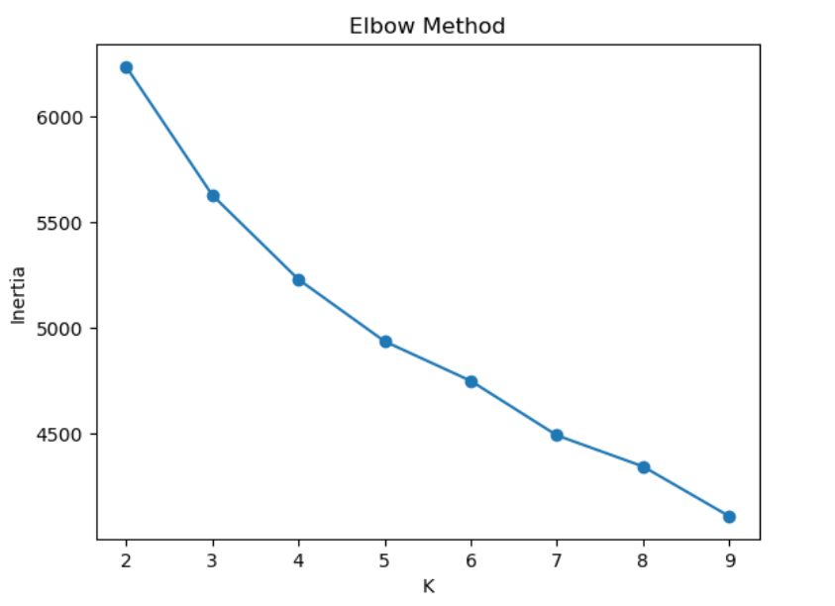

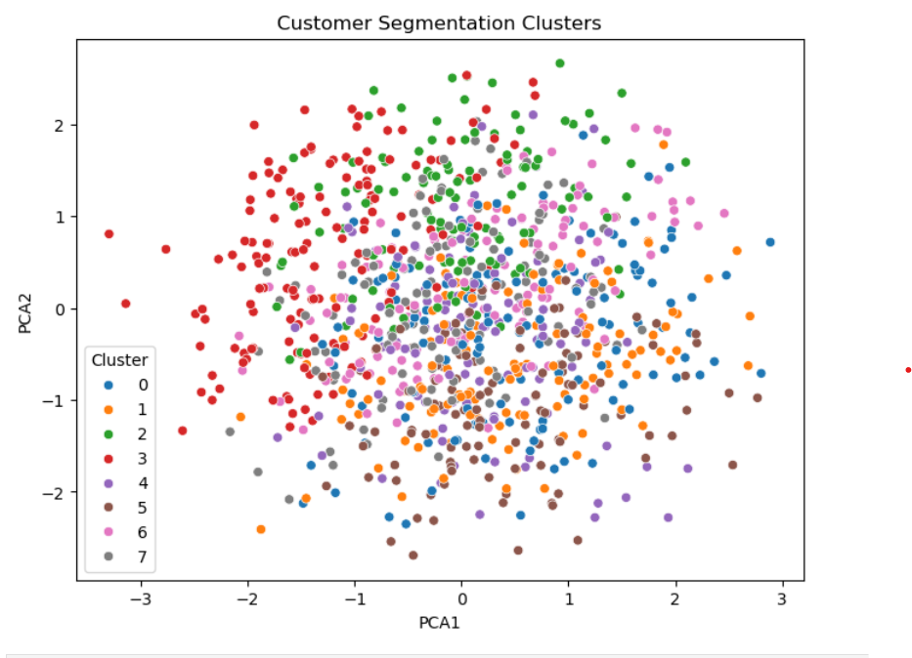

PROJECT INSIGHTS
Based on the clustering analysis performed using the K-Means algorithm, several meaningful insights were identified about customer behavior. The analysis helped uncover hidden patterns related to spending habits, service usage, contract preferences, and customer satisfaction indicators.
1. Customers Form 8 Meaningful Segments
Using the Silhouette Score, K = 8 clusters gave the best separation.
Each cluster represents a unique customer group based on spending behaviour, usage, contract preference, and service engagement.

2. Distinct Spending Patterns Across Clusters
Some clusters were made up of high-spending customers (high MonthlyCharges + high TotalSpent), while others represented budget-conscious users with lower spending.
This helps identify premium vs. regular customer groups.

3. Contract Type Strongly Differentiates Customers
Clusters naturally split into:
- Long-term contract users (stable, consistent spenders)
- Short-term or month-to-month users (more flexible, lower predictability)
Contract Type is one of the factors that divides customers clearly into different segments.

4. Device Usage Creates Unique Customer Profiles
Clusters with a higher number of DevicesConnected indicate tech-savvy or multi-device households.
Others with fewer devices show simpler usage patterns.
This helps in understanding service consumption behaviour.

5. Support Interaction Varies Across Segments
Some clusters contain customers who make frequent SupportCalls, indicating service dependence or frequent issues.
Other clusters rarely contact support, showing either:
- high satisfaction, or
- very low usage.
This helps identify customers requiring more service attention.

6. Age-Based Behavioral Differences Are Visible
Younger groups tend to fall into clusters with:
- lower TotalSpent
- more flexible contracts
- fewer devices
Older customers often appear in clusters with:
- long-term contracts
- higher TotalSpent
- stable usage patterns

7. Gender Has Minimal Impact
Clusters show that gender does not significantly influence purchasing or service usage patterns.
This means segmentation is driven mainly by behaviour, not demographics.

8. PCA Visualization Shows Well-Separated Clusters
The PCA scatter plot clearly displays 8 distinct color-coded groups, proving the segmentation model successfully identified meaningful customer groups.
This visual confirms the clustering quality.

Overall Insight
The segmentation reveals that customers differ mainly in:
- Spending levels
- Contract commitment
- Device usage intensity
- Support interaction frequency
- Age-based usage style
These insights help businesses:
- Personalize offers
- Improve customer experience
- Identify high-value groups
- Tailor service plans
SUGGESTIONS
- Develop targeted marketing strategies for each customer group
- Use the identified clusters to design personalized offers, pricing plans, or add-on services.
- High-value segments can be offered premium plans, while cost-sensitive groups may benefit from discounted or bundled packages.
- Improve customer engagement through personalized communication
- Tailor communication channels (SMS, email, app notifications) depending on each segment’s preferences and behavioural attributes.
- Provide segment-specific recommendations such as upgraded internet speed, international calls, or data add-ons.
- Enhance service features based on segment behaviour
- If a segment shows high usage of online security or streaming services, consider launching new products aligned with their preferences.
- For low-usage or inactive segments, introduce introductory offers or value-added services to increase engagement.
- Optimize resource allocation
- Allocate marketing budgets and customer support resources based on the business value and size of each segment.
- Focus more on high-revenue customer groups to maximize ROI.
- Monitor customer behaviour periodically
- Update the clustering model regularly since customer behaviour may change over time.
- This ensures that marketing strategies remain effective and relevant.
- Refine segmentation with additional features (optional improvement)
- Incorporate demographic data, usage patterns, or customer satisfaction metrics to achieve deeper and more accurate segmentation.
- This helps in building more actionable and business-aligned clusters.

CONCLUSION

The customer segmentation project using the Telco Customer Dataset successfully identified meaningful customer groups through K-Means clustering, supported by Elbow Method and Silhouette Score validation. The optimal number of clusters was selected based on a balance between model interpretability and cluster quality.
These segments provide valuable insights into customer behaviour, spending patterns, and service usage. By understanding the characteristics of each group, telecom companies can create more strategic, personalized, and effective business decisions.
Overall, segmentation helps in improving customer satisfaction, reducing unnecessary operational efforts, optimizing marketing strategies, and ultimately driving business growth.

